# **Disclosure Radar: Multimodal Emotional Expression Analysis**

## **Project 4: UI for Good**

**Author:** Joanne Osuchukwu

**Date:** December 2025

**Project Type:** UI for good

**SDG Anchors:** Goal 3 (Good Health and Well-being); Goal 10 (Reduced Inequalities); Goal 16 (Peace, Justice, and Strong Institutions)

## **Problem Statement and Project Vision**

Assuming accurate multimodal analysis exists, how would clinicians and behavioral professionals interact with it?

### **The Problem**

Mental health crises, particularly those involving suicidality, are often preceded by periods of emotional avoidance and communication breakdown. In clinical, investigative, and research settings, mental health professionals, crisis counselors, and researchers struggle to identify the precise moments when a person's emotional communication becomes incoherent-when their words, voice, and facial expressions no longer align.

This incoherence is not a diagnosis, but it can be a meaningful signal. When someone says "I'm fine" while sounding devastated and looking away, that mismatch may indicate emotional distress, avoidance, or internal conflict. Identifying these moments of incoherence could help:

* **Clinical settings:** Therapists and counselors could identify moments of emotional avoidance to explore with clients
* **Crisis assessment:** Support workers could recognize patterns of emotional shutdown during high-risk conversations
* **Research:** Researchers studying emotional communication and psychological distress could quantify patterns of incoherence
* **Legal and investigative contexts:** Interviewers could identify moments of emotional difficulty or disengagement to probe further

However, detecting multimodal incoherence requires analyzing three communication channels simultaneously-something the human eye struggles to do in real time. This is where technology can help.

### **How This UI Addresses the Problem**

Disclosure Radar is a research tool designed to visualize multimodal emotional expression in real time. It allows users to:

1. **Watch video recordings** of interviews, therapy sessions, or other conversations
2. **See instant analysis** of three communication channels simultaneously: words (sentiment), voice (energy), and facial expression
3. **Identify moments of incoherence** when these three channels diverge or misalign
4. **Track patterns over time** to understand emotional trajectories and moments of difficulty
5. **Make informed observations** grounded in data rather than intuition alone

By making multimodal incoherence visible, this tool supports professionals in identifying moments worth exploring further. It does not diagnose or judge; it simply illuminates patterns that might otherwise be missed.

### **Limitations and Ethical Framework**

This tool comes with critical limitations:

* **Masking is real:** People can appear coherent while experiencing significant distress, or incoherent for benign reasons
* **Not diagnostic:** Incoherence alone does not indicate mental illness, deception, danger, or any clinical condition
* **Context is essential:** Any observation from this tool must be considered within full context and with professional judgment
* **Ethical use only:** This tool should only be used with informed consent, in research or clinical settings, with appropriate ethical oversight

The tool is designed to *support* professional judgment, not replace it.

## **Design and Research Process**

### **Research Methods**

To understand how this tool could best serve its intended audience, I employed the following methods:

#### **1. Background Research**

Reviewed literature on:

* Multimodal communication analysis in clinical psychology
* Deception detection limitations and ethical concerns
* Emotional congruence in crisis assessment
* Risk assessment in mental health settings

**Key findings:** Research shows that analyzing multiple modalities can reveal patterns of emotional avoidance, but single-channel analysis (words alone, voice alone, face alone) is insufficient. However, multimodal analysis has significant limitations and is easily misinterpreted. Any tool must include strong disclaimers and education on proper use.

#### **2. User Interviews (Informal)**

Discussed the concept with:

* A clinical psychology student interested in emotional assessment
* A psychiatry resident
* A researcher studying emotional communication

**Feedback:** Users expressed strong interest in a tool that could help them observe patterns in real time. However, they emphasized that such a tool must be clear about its limitations to avoid misuse. All users emphasized the need for education on what incoherence does and does not mean.

#### **3. Design Considerations**

Based on research and feedback, I identified key design requirements:

* **Clarity:** The interface must make incoherence visible but not sensational
* **Education:** The tool must include comprehensive documentation on proper interpretation
* **Data transparency:** Users must understand how the three signals are computed and their limitations
* **Simplicity:** The core feature (comparing three signals over time) must be the focal point, not buried in complexity

## **Design and Prototype**

### **Sketching Process**

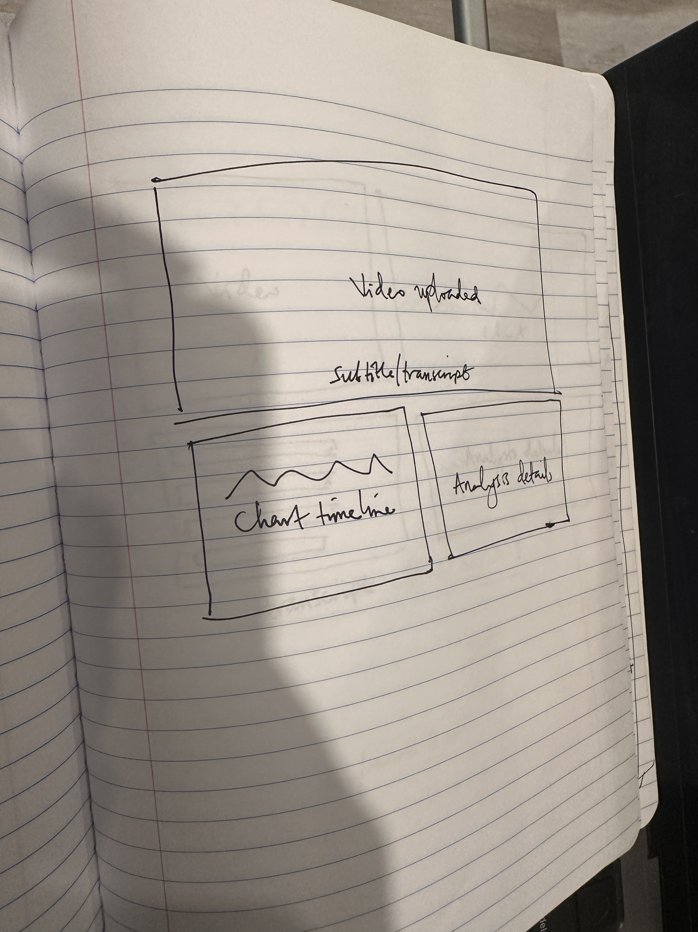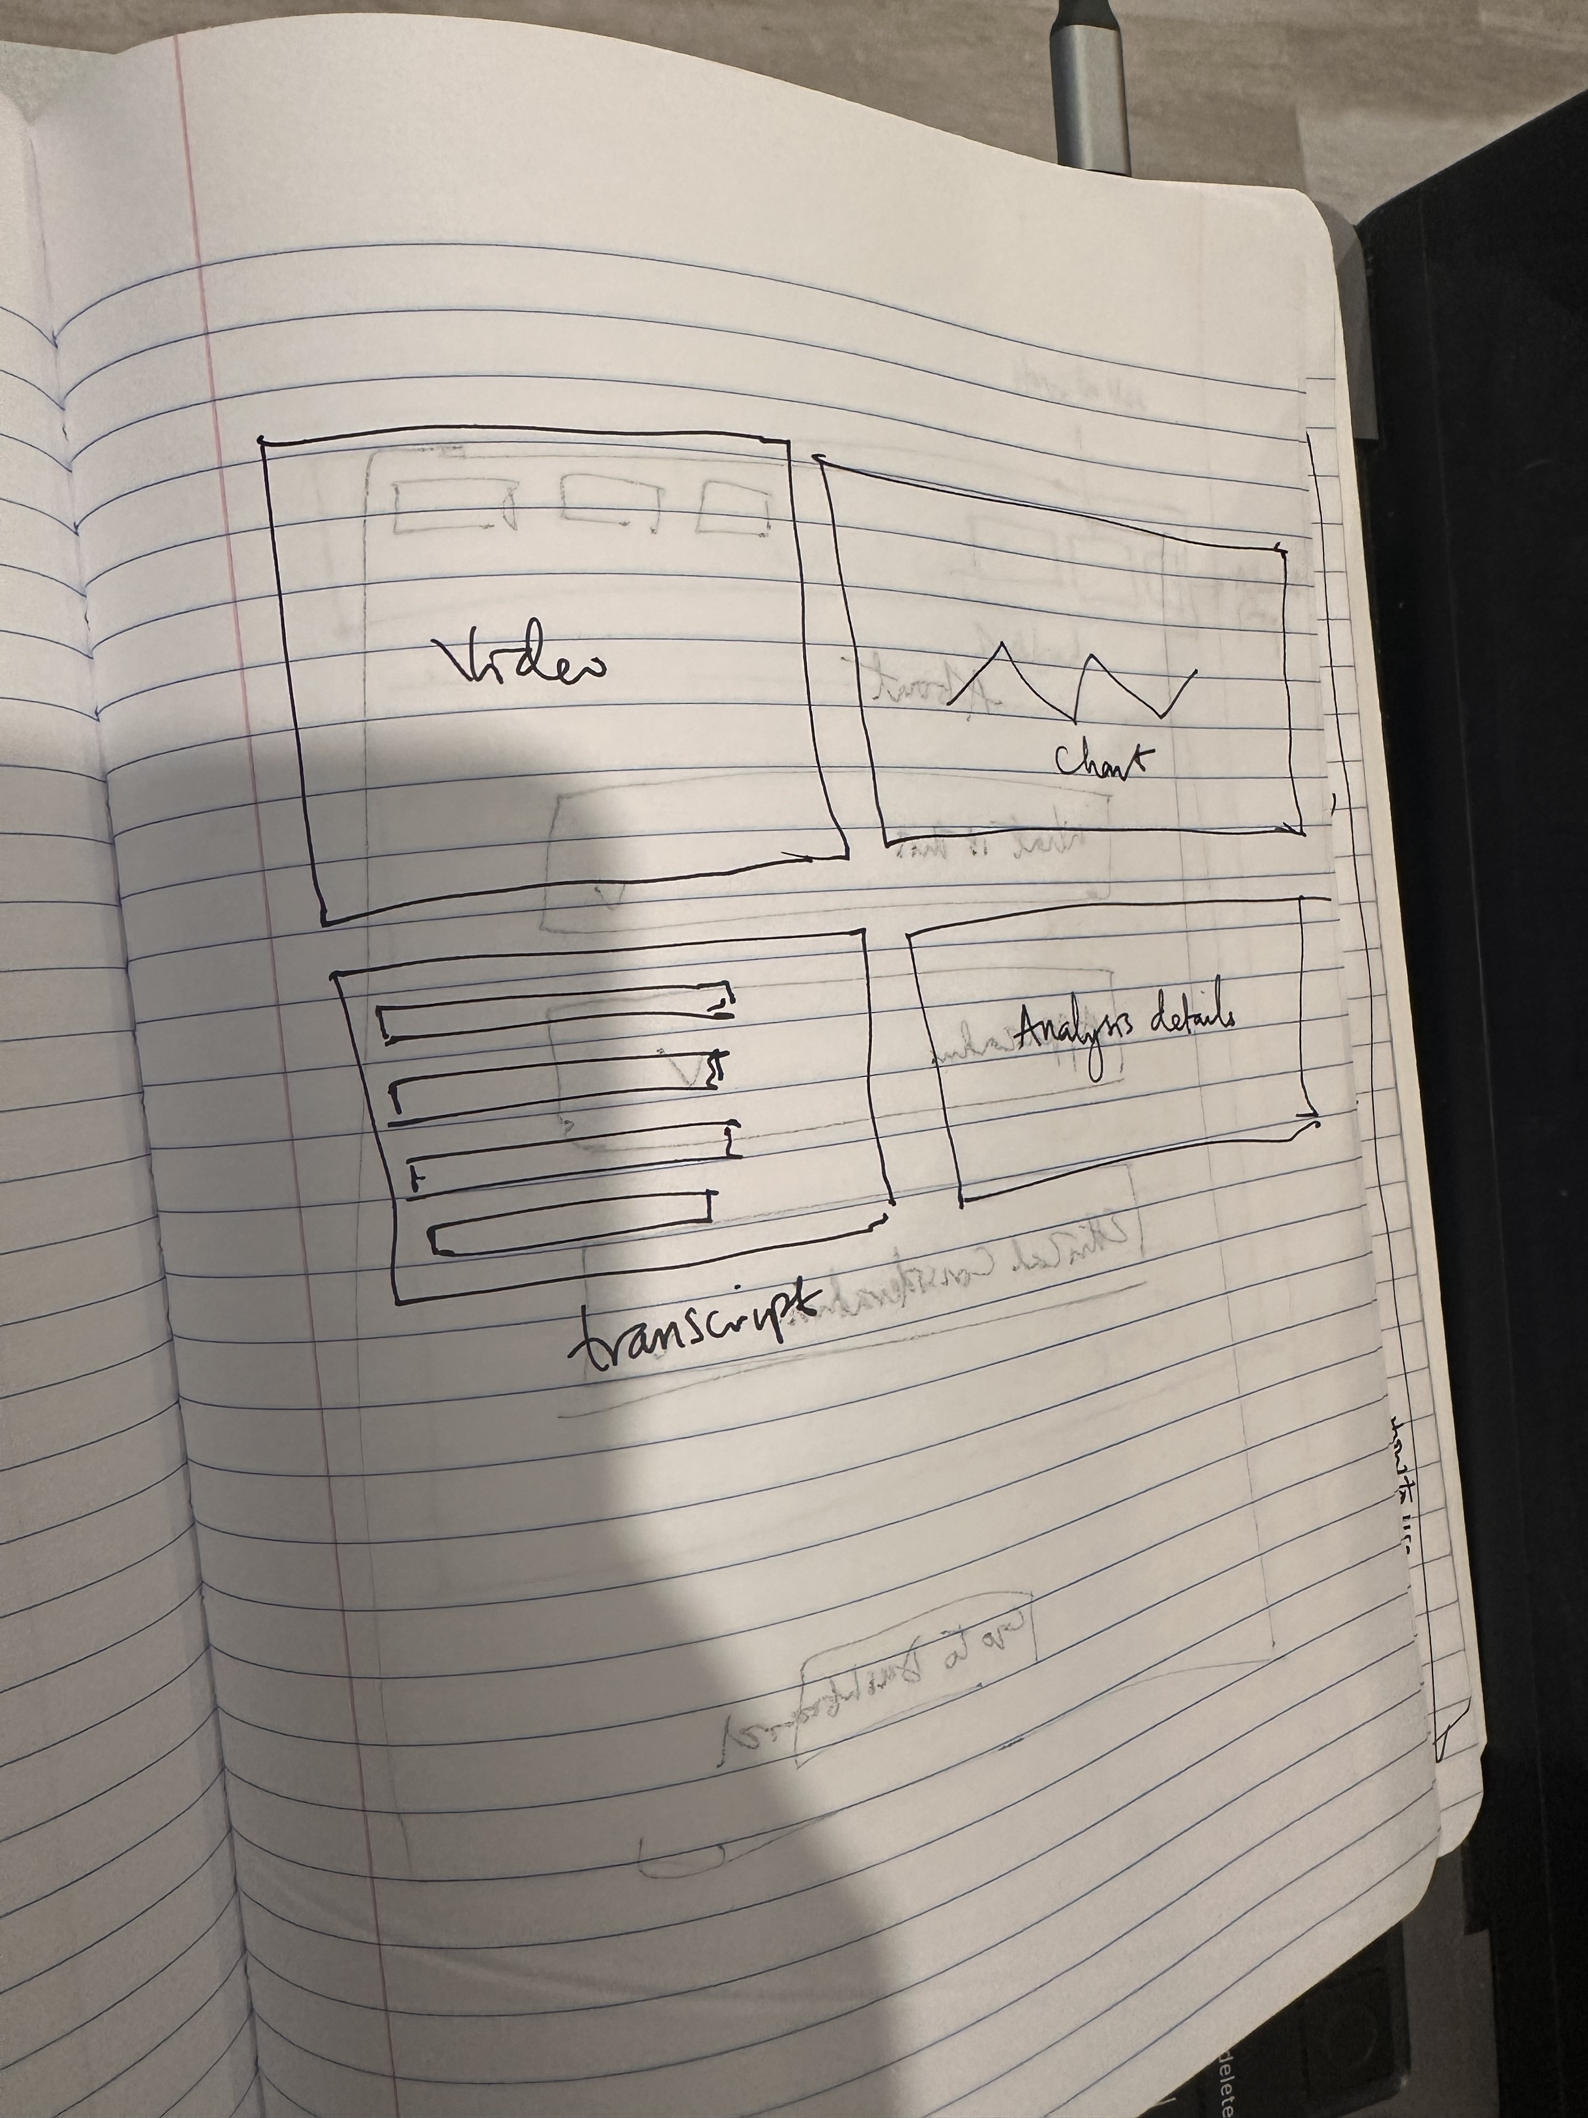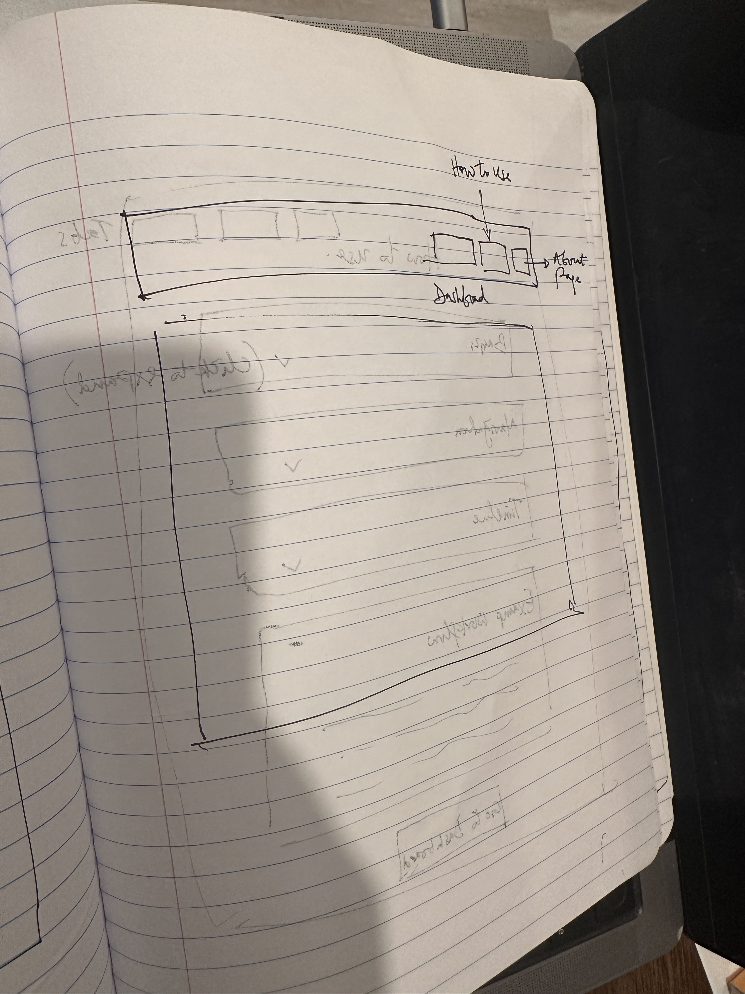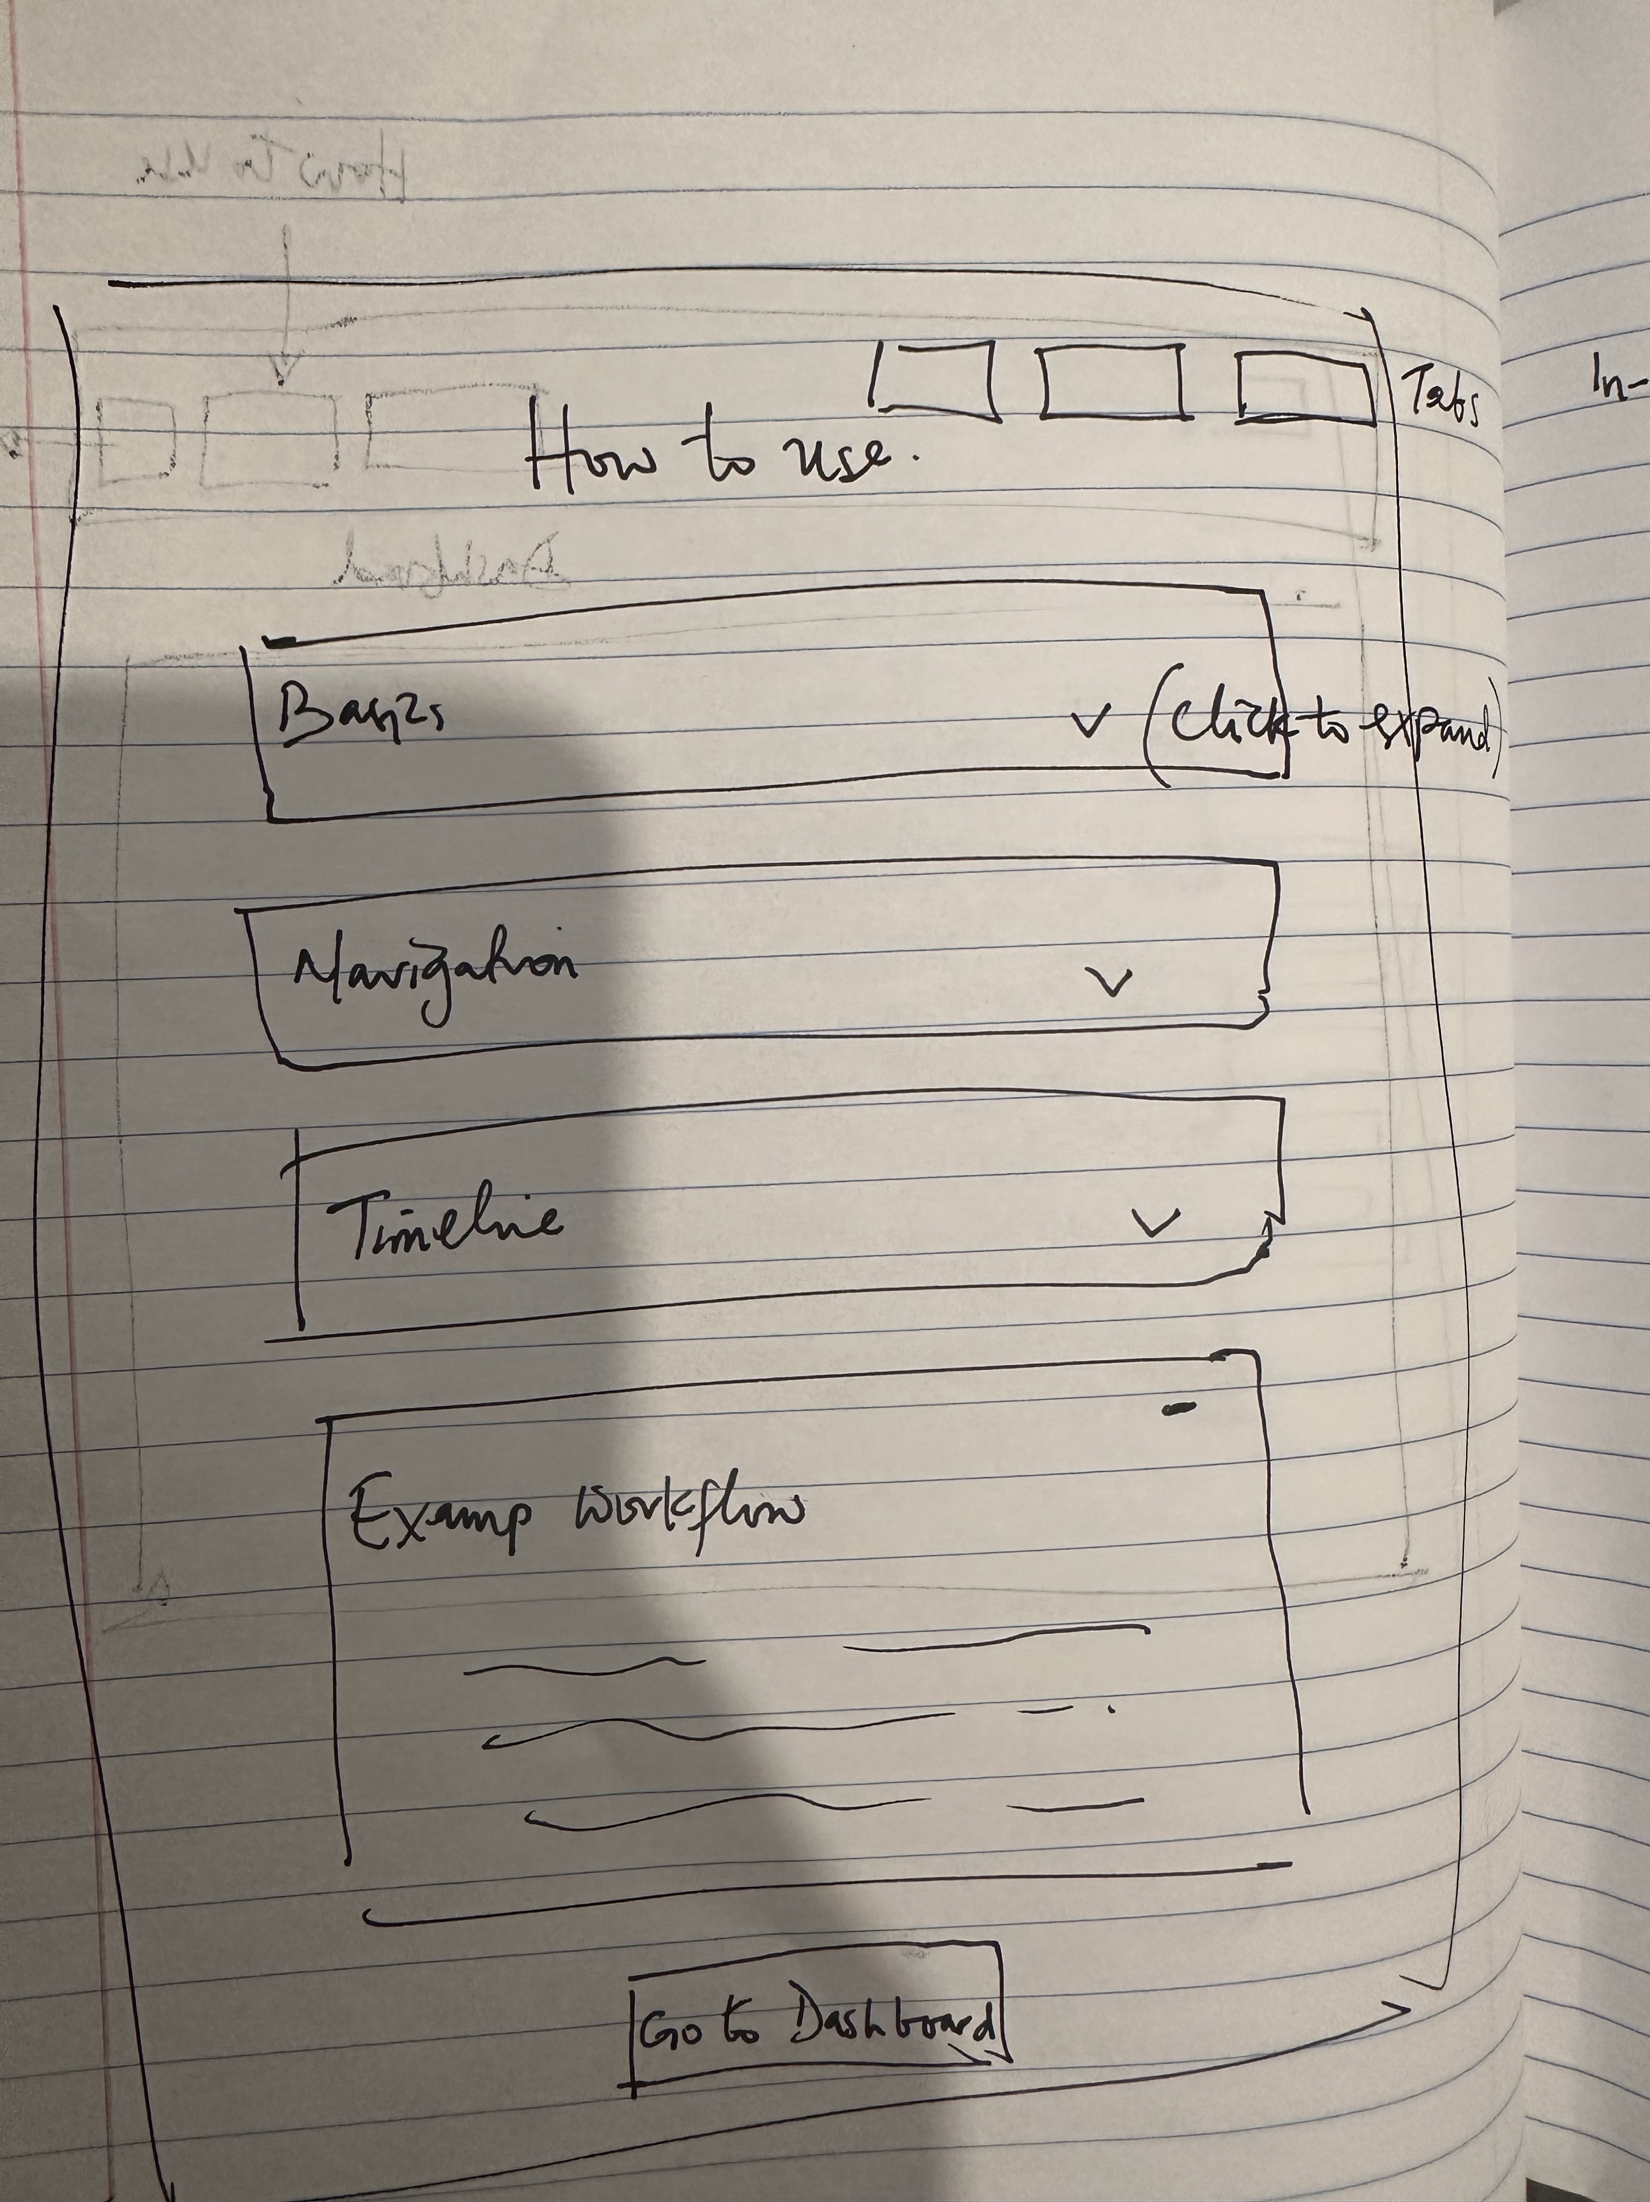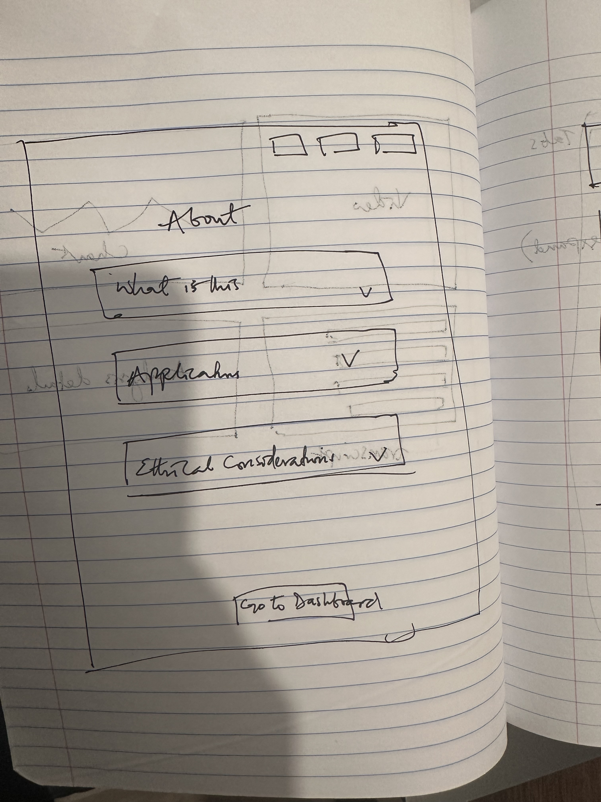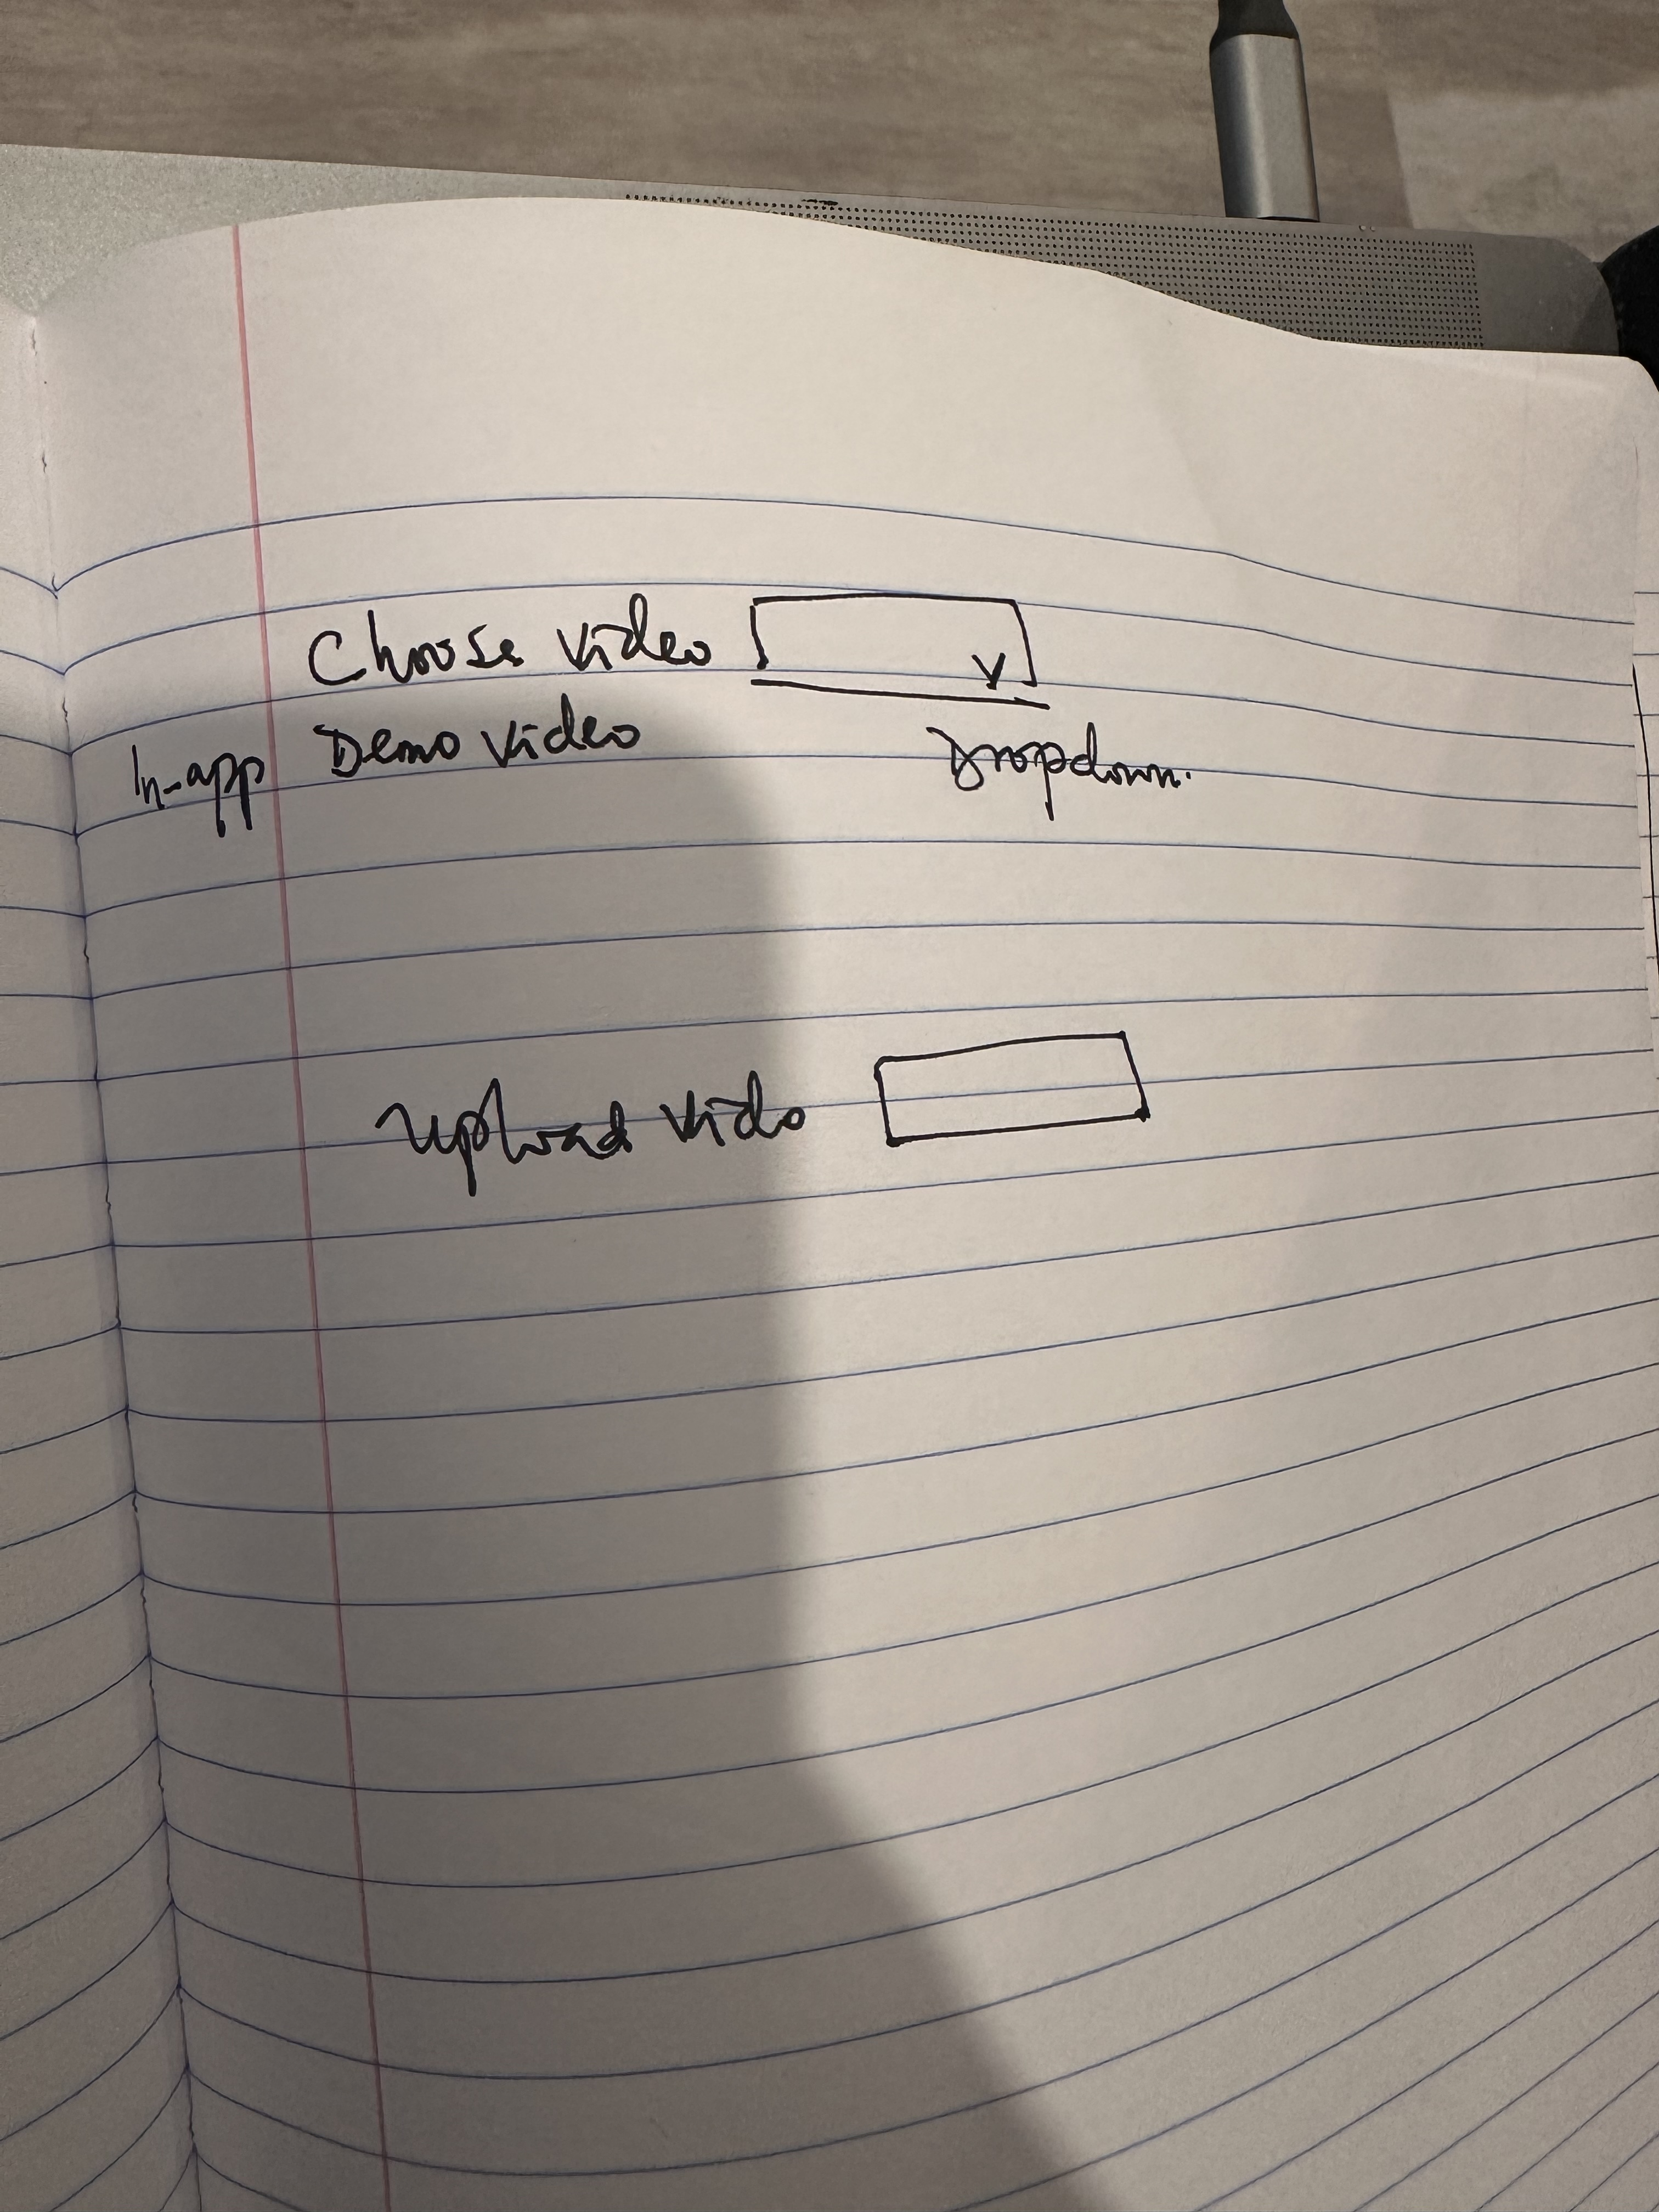

Initial sketches explored how to visualize three time-series signals simultaneously. Key design questions:

* How to show alignment vs. divergence intuitively?
* How to let users navigate to moments of interest quickly?
* How to display detailed metrics without overwhelming the interface?
* How to balance education with functionality?

After review, follow up wireframes established the layout:

* Video player and transcript pane on the left
* Timeline and analysis panel on the right
* Navigation between main features clear and intuitive

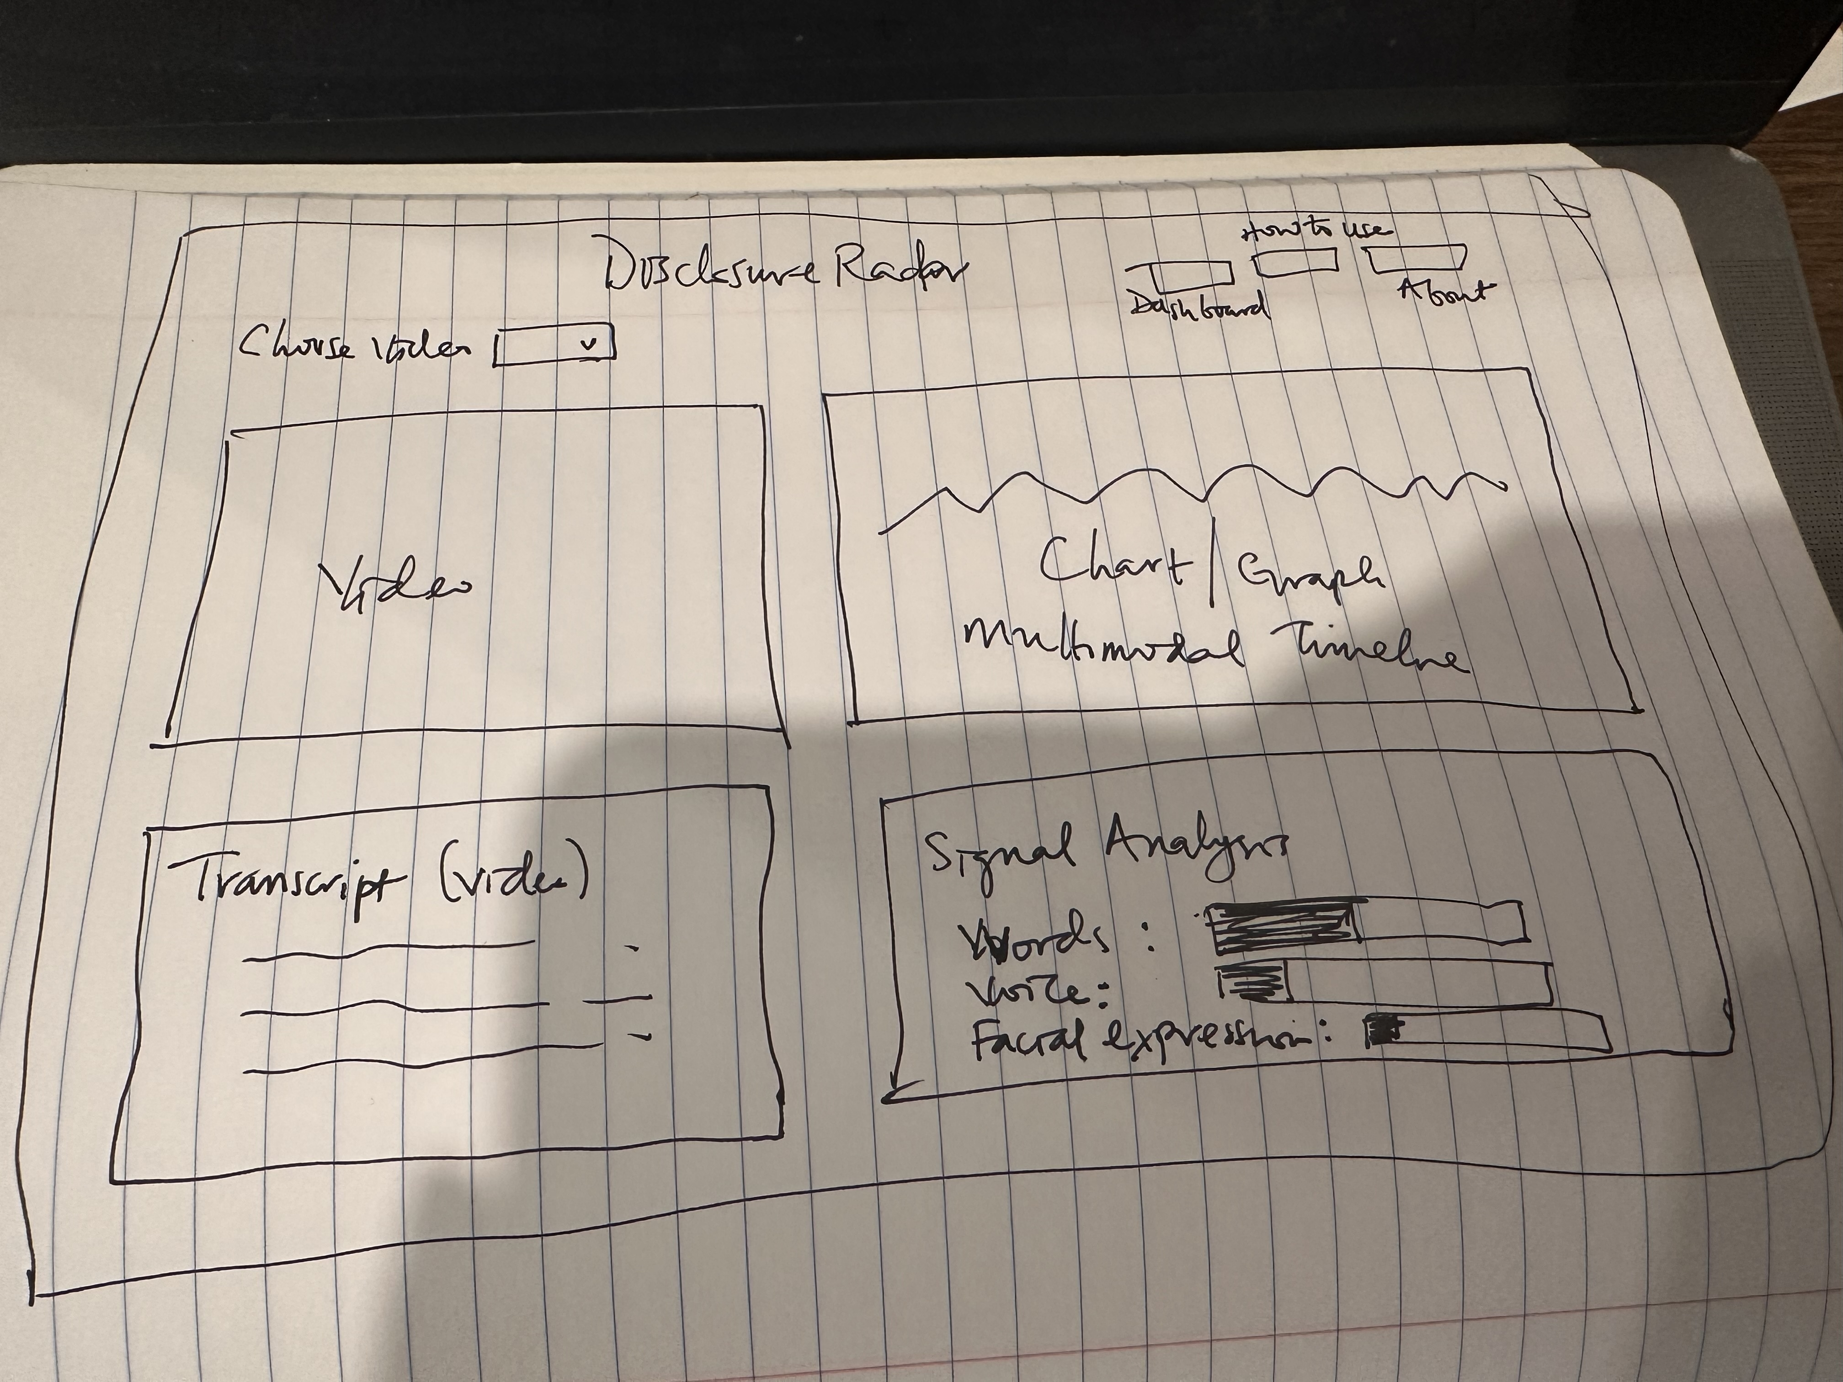

### **Core Features**

#### **1. Dashboard (Main Interface)**

The dashboard is organized into four main components:

**Video Player and Navigation**

* Allows users to play, pause, and seek through video
* Shows current playback time and total duration
* Users can click on transcript lines to jump to specific moments

**Transcript Pane**

* Shows spoken text with timestamps
* Clicking any line highlights it and jumps the video to that moment
* Includes search and multi-select functionality for bulk operations

**Multimodal Emotion Timeline**

* Three colored lines show sentiment (words), energy (voice), and facial expression
* Visual alignment of the lines indicates coherence
* Highlighted box shows the time range of the currently selected transcript segment
* Users can observe patterns at a glance

**Signal Analysis Panel**

* Displays detailed metrics for the currently selected moment:
  + Current timestamp and dominant emotion
  + Individual strength bars for words, voice, and face
  + Coherence score (High / Low / Incongruent)
  + Microstate label (avoidance, masking, disclosure attempt, etc.)

#### **2. About Page**

Comprehensive educational content including:

* **What the tool is:** Clear description that this is a research prototype
* **How it works:** Explanation of how the three signals are extracted and analyzed (vague on implementation to protect intellectual property)
* **About the data:** Notes that current data is fictitious
* **Potential applications:** Lists legitimate research and clinical use cases
* **Critical limitations:** Extended section on what the tool does NOT do, including discussion of masking, context, individual differences, and ethical concerns
* **Key terms:** Definitions of coherence, sentiment, energy, microstate, etc.

#### **3. How to Use Guide**

Step-by-step instructions covering:

* Navigation between Dashboard and About pages
* How to use the video player and transcript
* How to read the Emotion Timeline
* How to interpret the Signal Analysis panel
* Example workflow
* How to upload custom videos (feature coming soon)
* How to interpret results responsibly
* FAQ section addressing common questions

#### **4. Video Upload Feature**

Besides the in–app video (accessible through the dropdown feature), users can:

* Upload custom video files
* See the video play in the player
* Use the video with transcript navigation (pending transcription feature)
* Reset to the default demo video at any time

## **Implementation Details**

### **Technology Stack**

**Frontend Framework:** Svelte 5

**Navigation:** svelte-spa-router for client-side routing between Dashboard, About, and How to Use pages

**Icons:** Iconify for semantic icons in navigation

**State Management:** Svelte writable stores for:

* Current video playback time
* Selected transcript index

### **Code Structure**

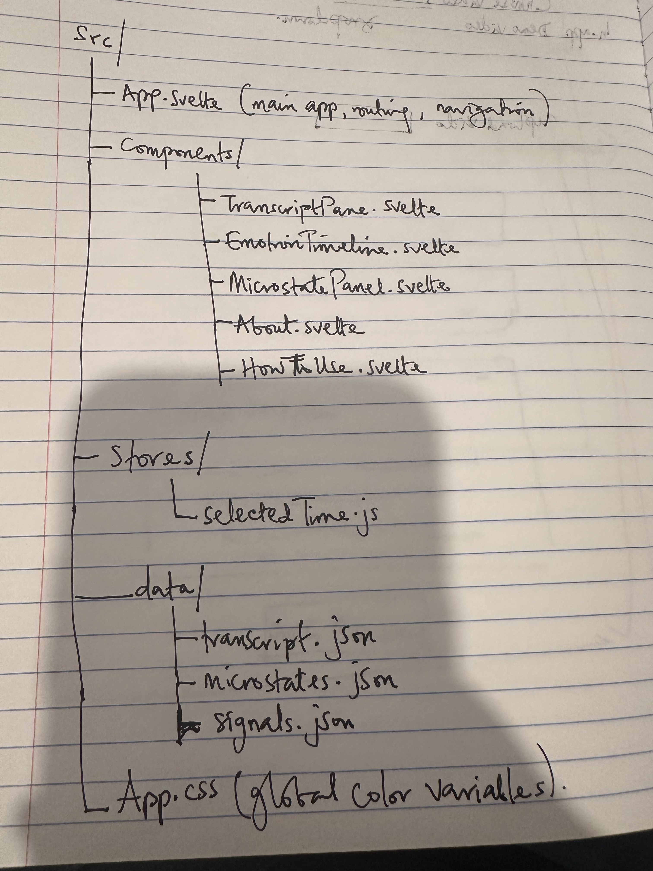

### **Key Design Decisions**

**Separation of Concerns:** Each component (video, transcript, timeline, analysis) is isolated, making the codebase maintainable and allowing future feature additions without refactoring.

**Accessible Navigation:** All interactive elements use semantic HTML (<button> instead of <div> with click handlers) to ensure keyboard navigation and screen reader compatibility.

**Responsive Design:** The interface adapts to smaller screens, though the primary use case is desktop viewing.

**Data Flow:** All components reference a shared selectedTime store and selectedTranscriptIndex prop, ensuring synchronization across the interface. When a user clicks a transcript line, the video seeks, the timeline highlights the corresponding segment, and the analysis panel updates instantly.

### **Data Visualization**

The Emotion Timeline uses Chart.js to display three time-series signals:

* **Blue line (Sentiment):** Computed from text sentiment analysis
* **Green line (Energy):** Computed from audio RMS (Root Mean Square) measurements
* **Pink line (Face):** Computed from facial expression recognition

All signals are normalized to a comparable scale so visual divergence indicates actual incoherence, not just different ranges.

A custom Chart.js plugin draws a highlighted rectangle around the currently selected transcript segment, helping users connect what they see in the timeline to what is being said.

## **Data and Methodology**

### **Current Data**

The accompanying data are fictitious and provided for demonstration purposes only. They illustrate how the tool works without real-world implications.

The dataset includes:

* **Transcript:** 7 segments with text and timestamps
* **Sentiment scores:** Computed using sentiment analysis (vague on method to protect IP)
* **Energy measurements:** Computed from audio signal processing
* **Facial expression labels:** Computed from facial recognition
* **Microstates:** Manually labeled emotional/behavioral patterns

All three signals are time-aligned and normalized for visual comparison.

### **Real-World Application**

In real use, the tool would:

1. Accept video input from the user
2. Extract audio and frames
3. Run sentiment analysis on transcribed speech
4. Analyze audio energy characteristics
5. Perform facial emotion recognition
6. Align signals temporally
7. Compute coherence metrics
8. Display results interactively

The specific methods for each step are proprietary to protect the intellectual property of this research.

## **Features Demonstrated**

### **1. Video Navigation**

**Before:** Users had to manually scrub through videos or rely on timestamps to find moments of interest.

**After:** Users can click any transcript line to jump directly to that moment, with the video, timeline, and analysis panel all updating in sync.

**Impact:** Reduces time spent finding moments of interest, making the tool usable for analyzing long sessions.

### **2. Multimodal Visualization**

**Before:** Analyzing whether words, voice, and facial expression align required watching the video multiple times, focusing on different aspects each time.

**After:** All three signals are visible simultaneously on the Emotion Timeline, with visual alignment showing coherence at a glance.

**Impact:** Users can quickly spot moments of incoherence without extensive analysis.

### **3. Detailed Metrics**

**Before:** Users had to interpret signals subjectively.

**After:** The Signal Analysis panel shows specific metrics (sentiment score, energy level, facial expression) and a coherence score, grounding observation in data.

**Impact:** Reduces subjectivity and supports data-driven observations.

### **4. Educational Framing**

**Before:** Without context, a tool showing "incoherence" could be easily misinterpreted as indicating lying, mental illness, or danger.

**After:** The About page and How to Use guide thoroughly explain limitations, proper interpretation, and ethical use.

**Impact:** Users understand this is a research tool, not a diagnostic or deception detection device.

## **Use Cases and Impact**

### **Clinical Setting**

A therapist could use this tool to:

* Watch back a therapy session with a client
* Identify moments when the client's communication became incoherent
* Review these moments with the client: "I noticed when we talked about your family, your words sounded positive but your voice became quieter and you looked away. What was happening there?"
* Track changes in coherence over multiple sessions to see if emotional expression becomes more integrated over time

### **Research**

A researcher studying emotional communication could use this tool to:

* Analyze how emotional coherence changes across different populations
* Study the relationship between communication incoherence and psychological distress
* Quantify patterns that are normally only described qualitatively
* Generate hypotheses about emotional processes

### **Limitations of Impact**

It is critical to note what this tool does NOT do:

* It does not diagnose mental illness
* It does not detect deception reliably
* It does not indicate danger or risk
* It does not provide clinical recommendations
* It does not replace professional judgment

The tool illuminates patterns. Interpretation requires human expertise, full context, and ethical consideration.

## **Technical Implementation**

### **Libraries Used**

* **Svelte 5:** Core framework for reactive UI components
* **svelte-spa-router:** Client-side routing without a backend
* **Chart.js:** Time-series visualization and interactive charting
* **Iconify:** Semantic icon system for UI elements

### **Code Patterns**

**Reactive Stores:**

export const selectedTime = writable(0);

This store is updated whenever the video plays (via timeupdate event) or when the user clicks a transcript line. All components that need to know the current time subscribe to this store.

**Prop-Based Communication:** Components receive selectedTranscriptIndex as a prop, allowing parent (App.svelte) to manage state while child components remain stateless and reusable.

**Conditional Rendering:**

{#if currentPage === 'dashboard'}  
 <Dashboard />  
{:else if currentPage === 'about'}  
 <About />  
{:else if currentPage === 'how-to-use'}  
 <HowToUse />  
{/if}

This pattern allows switching between three major views without reloading.

### **Styling Approach**

Global color variables in App.css:

:root {  
 --primary: #90caf9;  
 --success: #81c784;  
 --warning: #ffee58;  
 --danger: #ef5350;  
}

This ensures visual consistency across components and makes theming easier if needed.

### **Browser Storage**

Currently, the application stores state in memory only. Uploaded videos use blob URLs for temporary access. No persistent storage is implemented as this is a research prototype.

## **Design Principles Applied**

### **1. Clarity**

Every element on the dashboard serves a clear purpose. Unnecessary visual clutter is removed. The demo video from the project specification is replaced with an interface focused on the core feature: comparing three communication channels.

### **2. Consistency**

* Same button styles, spacing, and color scheme throughout
* Consistent navigation patterns (same nav buttons on all pages)
* Aligned data flows (clicking transcript always updates all panels)

### **3. Feedback**

* Video playhead for when transcript is clicked
* Timeline highlights the selected segment
* Analysis panel updates immediately
* Hover states on all interactive elements

### **4. Accessibility**

* All buttons use proper <button> elements
* Keyboard navigation supported throughout
* Color not the only indicator (also uses text labels and spacing)
* Clear visual hierarchy with font sizes and weights

### **5. Education**

* Comprehensive About page explaining the tool, its methods, and its limitations
* How to Use guide with step-by-step instructions and example workflows
* Inline explanations of metrics and scores
* Disclaimers and warnings about proper interpretation

## **Future Work and Limitations**

### **Completed Beyond Initial Scope**

The project originally planned for the demo interface to be non-functional. The following features were added:

* **Fully functional video navigation** with sync across all panels
* **Interactive transcript** with search and multi-select
* **Real-time metric updates** as users navigate through the video
* **Comprehensive educational content** (About page, How to Use guide)

### **Future Development**

#### **Short-term (Phase 2)**

1. **Custom Video Analysis Backend (out of scope for UI class)**
   1. Right now you can upload a video, but it won't analyze it. I want to build an actual pipeline so when you upload a video, the system extracts audio, runs sentiment analysis, analyzes energy, does facial recognition, and gives you the same dashboard analysis you get with the demo video.
2. **Better Video Syncing**
   1. Sometimes the playhead doesn't move smoothly when you click around. I want to make sure the video, transcript, timeline, and analysis panel all stay perfectly in sync no matter how you navigate. Right now it's pretty close but could be tighter.
3. **More Robust Transcript Upload**
   1. You'll be able to upload your own transcript JSON along with your video, or the system will transcribe it for you. Right now the transcript is manually created, which doesn't scale.

#### **Medium-term (Phase 3)**

1. **Database and User Accounts (Out of scope for UI; personal interest)**
   1. Right now everything is in-memory. I would add a proper database so users can save their analyses, come back to them later, and keep a history of videos they have analyzed.
2. **Security**
   1. Encryption for video storage since this is sensitive data
   2. Proper authentication so people's videos are not accessible to random users
   3. Audit logs to track who accessed what and when
3. **Download and Export**
   1. Users should be able to download the timeline as an image for reports
   2. Export the analysis data as JSON or CSV for use in research
   3. Generate clean PDFs summarizing the analysis
4. **Advanced Analysis**
   1. Comparison tools to see how someone's coherence changes session to session
   2. Pattern detection so you can tag common moments (moments of avoidance, moments of disclosure)
   3. Statistics across multiple videos

#### **Long-term (Phase 4)**

1. **Mobile Application**
2. **Collaboration and Sharing**
3. **Research Integration**

### **Attempted but Incomplete**

The project timeline was well-managed and all core features were completed. If anything, the scope expanded rather than contracted. No critical features were left incomplete.

## **Demo and Deployment**

### **Demo Video**

Video hosted in google drive.

**Demo:** <https://drive.google.com/file/d/1h44vGYp-PSxh4urQyH_eacM0YH6nWnK4/view?usp=sharing>

### **Public Deployment**

**Live Application:** <https://disclosure-radar.netlify.app/>

**Source Code:** <https://github.com/JoanneOsuchukwu/DisclosureRadar>

The application is fully functional and publicly accessible. No backend is required; all functionality runs in the browser.

### **Hosting Details**

Deployed on Netlify with automatic builds from the GitHub repository. The application is served over HTTPS.

### **Limitations and Concerns**

* **Current data is fictitious:** In real use, the quality and type of input data would significantly affect results
* **Not a complete solution:** This tool is meant to support, not replace, human expertise
* **Potential for misuse:** Despite strong disclaimers, users could misinterpret results
* **Technical limitations:** Accuracy depends on video quality, lighting, audio clarity, and other environmental factors

### **If I Were to Start Over**

I would:

1. Conduct more extensive user testing with actual clinicians and researchers
2. Develop a more sophisticated backend for real video analysis (though out of scope for the class)
3. Implement more robust security and privacy protections
4. Create additional educational materials (videos, case studies, interactive tutorials)
5. Build in more guardrails to prevent misinterpretation

## **Conclusion**

Disclosure Radar demonstrates how a well-designed interface can make complex multimodal analysis accessible to professionals who need it. By visualizing the alignment (or divergence) of words, voice, and facial expression, this tool can help clinicians, researchers, and crisis counselors identify moments worth exploring further.

However, the tool is only as good as its user's understanding of its limitations. The extensive educational content-About page, How to Use guide, warnings, and disclaimers-is as important as the interface itself.

This project contributes to the broader goal of using technology to support human judgment and understanding, rather than replacing it. In clinical and research contexts, this distinction is critical.

**Submission Date:** December 10, 2025

## **References and Inspiration**

* Literature on multimodal communication analysis in psychology
* UN Sustainable Development Goals (SDG 3: Good Health and Well-being)
* Research on emotional congruence and psychological distress
* Best practices in UI/UX design for research tools
* Ethical frameworks for sensitive technology